# Ex No: 2 BUILD A SIMPLE NEURAL NETWORKS

**AIM:**

To build a simple neural network using Keras/TensorFlow.

# PROCEDURE:

1. Download and load the dataset.
2. Perform analysis and preprocessing of the dataset.
3. Build a simple neural network model using Keras/TensorFlow.
4. Compile and fit the model.
5. Perform prediction with the test dataset.
6. Calculate performance metrics.

# PROGRAM:

# first neural network with keras make predictions from numpy import loadtxt

from tensorflow.keras.models import Sequential from tensorflow.keras.layers import Dense

# load the dataset

dataset = loadtxt('pima-indians-diabetes.csv', delimiter=',') # split into input (X) and output (y) variables

X = dataset[:,0:8] y = dataset[:,8]

# define the keras model smodel = Sequential()

model.add(Dense(12, input_shape=(8,), activation='relu')) model.add(Dense(8, activation='relu')) model.add(Dense(1, activation='sigmoid'))

# compile the keras model

model.compile(loss='binary_crossentropy', optimizer='adam', metrics=['accuracy']) # fit the keras model on the dataset

model.fit(X, y, epochs=150, batch_size=10, verbose=0) # make class predictions with the model

predictions = (model.predict(X) > 0.5).astype(int)

# summarize the first 5 cases for i in range(5):

print('%s => %d (expected %d)' % (X[i].tolist(), predictions[i], y[i]))

# OUTPUT:

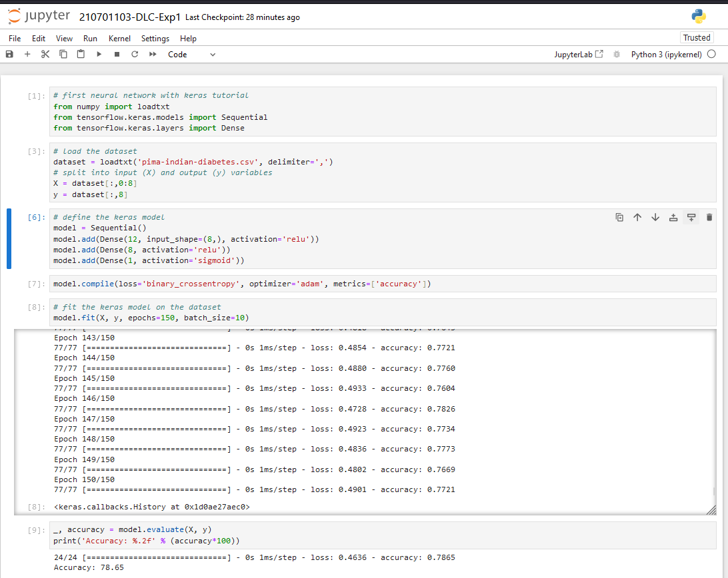

**RESULT:**

Thus a simple neural network using Keras/TensorFlow is built.